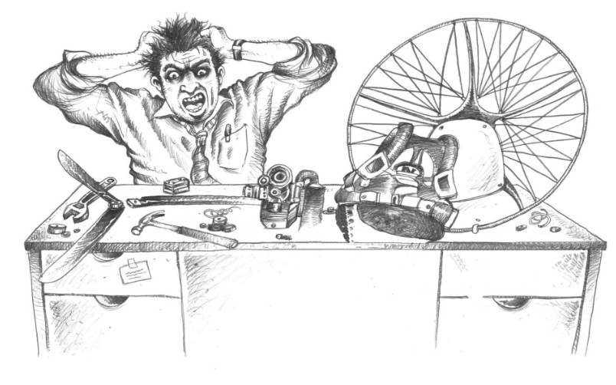

Walbro WB37C Carburettor: Overhaul, Setup and Tuning for Paramotors
Technical note for instructors, technicians and pilots · Version 1.0 · 30 October 2026
Paramotor SA (Pty) Ltd t/a Apex Adventures · SACAA DTO 0012

Technical notes · General

Scope. This note covers the Walbro WB37C (and its close relative the WB32) diaphragm carburettor as used on paramotors. It is a compiled summary of three supplied documents (see Sources, last page). Figures marked article come from a pilot's tuning article written for the Simonini Mini 2 Plus, Solo 210, Vittorazzi Moster 185 etc engines. They are good starting points, not universal specifications. Where your engine manufacturer publishes a figure, the manufacturer's figure wins.

1. Identification: WB32 and WB37C
The two carburettors are almost identical in build and operation. Both are butterfly-valve diaphragm carburettors with a HIGH needle, a LOW needle and an idle (throttle stop) screw.
Item | WB32 | WB37C
Main jet | Small hole in the venturi wall | Elevated main jet standing in the venturi
Check-valve membrane (main jet) | Fitted | Not fitted as standard
Service kit | K10-WB | K10-WB (same kit)

Source: article. Confirm the kit part number with your supplier before ordering.
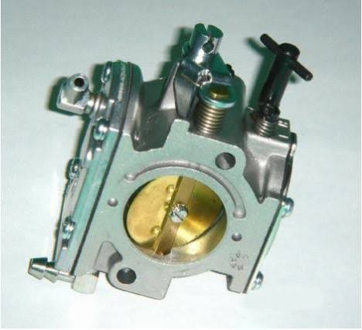
Walbro WB-series carburettor: throttle disc and brass venturi in the bore, HIGH needle top right.
Needles. The HIGH needle sets the flow to the high-speed (main) jet. The LOW needle sets the flow to the idle jet and the two mid-range jets. The LOW needle is more sensitive than the HIGH needle and is the one that does the most damage if it is set lean.

2. How it works (short version)
A diaphragm carburettor works in any attitude because it has no float. Instead:
- The pump. Crankcase pressure pulses reach the fuel pump diaphragm through the pulse port. The pump draws fuel from the tank and pushes it through the inlet screen to the inlet needle.
- The metering chamber. The metering spring holds the inlet needle shut through the metering lever. Engine vacuum pulls the metering diaphragm in, the lever lifts off, and the needle opens, so fuel flows in to replace what the engine used.
- The jets. Fuel goes from the metering chamber to the HIGH jet and the LOW jets. The main nozzle has a check valve so air cannot bleed back in at idle.
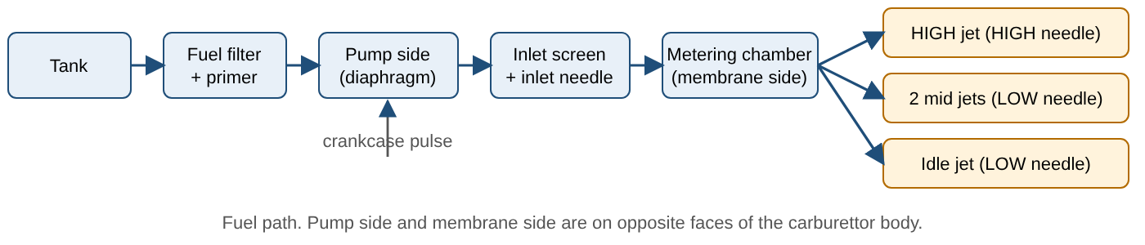

3. Fuel system requirements (before the carburettor gets the blame)
Most carburettor complaints are fuel-system or air-leak problems. Check these first.
- Continuous rise in the fuel line from tank to carburettor. This avoids vapour lock in the line.
- Primer pump mounted vertically; paper-type fuel filter in the line (the article mounts it horizontally).
- Fuel valve at the carburettor end; vent with a shut-off and a one-way valve (the article uses a bicycle "French" valve) to prevent vent leakage.
- The fuel system must hold 5 PSI without leaking. Test: disconnect the fuel line at the carburettor, close all vents, make sure the tank cap is secure, then carefully pressurise through the line to 5 PSI. It must hold for several minutes. If it drops, spray soapy water on every joint and find the leak.
- Do not fly with a leaking fuel system.
- Internal fuel screen. Do not remove it. A clogged screen lets the engine run at reduced rpm so you can fly home; with the screen removed, dirt reaches the membrane side where the tolerances are tight and the engine can stop abruptly.
- Typical clogged-filter symptom: the engine "dies" at full power but runs fine at lower rpm, because high fuel flow is being restricted and the mixture leans out.
- Fuel quality. Walbro states its carburettors tolerate up to 10% ethanol, 5% methanol and 11% MTBE. Alcohol blends age the flexible parts, which is one reason regular rebuilds matter.
- Crankcase leaks. If a correct rebuild and tune still will not run well, suspect a crankshaft seal or carburettor manifold leak. Test: remove carburettor and exhaust, block both openings, pressurise the crankcase through the pulse port exit, spray soapy water over everything. It should hold 5 PSI for several minutes.

4. Maintenance intervals
The sources do not agree, and none of them is an Apex rule. The interval to adopt is the CFI's decision.
Task | Interval given | Source
Check internal fuel filter/screen is free of debris | Every 10 hours | Article
Replace pump membrane | Every 2 years | Article (author's practice)
Full carburettor rebuild | Every 2 years (author flies about 50 h/year); "some say 5 years" | Article
Full carburettor rebuild | Every year, whether the engine is run or not | Southwest Airsports WG-8 page
Purge the fuel system | If the paramotor is stored more than a few weeks | Southwest Airsports WG-8 page
Check fuel system holds 5 PSI | After any fuel-system work or whenever a leak is suspected (timing is our suggestion; test method from the article) | Article

Apex interval (CFI to confirm): rebuild every ______________ months or ______________ hours, whichever comes first.

5. Tools and parts
- Service kit K10-WB (the article uses it for the new gaskets, membranes and filter screen)
- Pressure gauge with hand pump for the fuel inlet (the Walbro manual uses its 57-11 pressure tester); a few drops of fuel or CRC 5-56 for the needle valve well, Also available from Vittorazzi Dealer
- Metering-lever gauge (Walbro 500-13) or a rule that reads 1.45 mm
- Small screwdrivers, needle-nose pliers, soft-jawed vice, magnifying glass, pen light
- Carburettor spray cleaner and compressed air; clean towel or soft paper
- A tachometer (compulsory for tuning). CHT and EGT gauges are strongly recommended.

6. Overhaul procedure
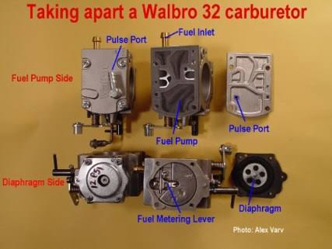
Walbro 32 stripped down: fuel pump side (pulse port, fuel inlet, pump cavity) and diaphragm side (metering lever, diaphragm). Photo: Alex Varv.
Work on a clean, well-lit bench with the carburettor on a towel or clean soft paper. Walbro notes that about 90% of carburettor problems come from dirt and fuel gums.
- Remove the carburettor from the engine.
- Wash it in clean solvent before opening it.
- Disassemble both sides. Remove all gaskets, all membranes, the internal needle valve assembly (inlet needle, lever and spring), the filter screen, and the external HIGH and LOW needles. The throttle disc assembly does not need to come off.
- Inspect the mixture needles. The tips must be free of grooves. A ring you can see is acceptable, but you must not be able to feel it with a fingernail. Grooved needles have ruined seats as well. If the carburettor is hard to adjust, always too rich or too lean, suspect the needles and their seats.
- Clean the inlet seat with a cotton swab soaked in carburettor cleaner. Never put hard tools into the seat. A worn seat will not hold pressure and the needle assembly must be replaced.
- Clean every passage with spray cleaner and compressed air. Do not drill or poke the passages: the holes are precisely sized and any change affects idle and mixture. Do not soak in dip cleaner longer than 15 minutes, and remove all rubber and plastic first.
- Check the channel from the pump side to the inlet needle seat is clear (compressed air). The jets are very small and clog easily. Clean fuel is a must.
- Check the check valves on the pump side and the fuel pump cavity for scratches or nicks. Damaged sealing surfaces reduce pump capacity or let the pump empty during storage.

Reassembly
- Pump side: fit the new filter screen, then the membrane first, then the gasket, then the cover. The crush ribs on the cover must not be damaged. Tighten the 4 screws diagonally and gradually. Do not overtighten.
- Membrane side: fit the inlet needle, lever and spring.
- Set the metering lever height. With the body gasket off, measure from the carburettor body to the top of the metering lever. For the WB carburettors the article gives 1.45 mm. Bend the lever carefully to the correct value. Walbro's own tool for this is gauge 500-13.
Conflict between sources on lever height. The Walbro manual says a lever set too high runs rich and too low runs lean. The article says too little distance floods the carburettor and too great a distance leans it. The two probably describe the same thing measured from opposite directions. Do not rely on either "direction" statement: set the measurement with the gauge, then confirm with the pop-off and re-seat test in section 7.
- Check POP-OFF and RE-SEAT pressure (section 7) with the membrane off, then replace the gasket used for the test with the new one from the kit.
- Fit the check-valve membrane (WB32 only, see section 10 for the WB37C).
- Body gasket, then membrane, then cover plate. Make sure the fingers of the metering lever engage the groove in the membrane cap. Tighten the 4 cover screws diagonally and gradually. Do not overtighten.
- Vent hole. The metering cover has a vent hole. Fit the cover so the hole faces away from cooling air (so dust is not blown in) or downward if the cooling fan does not blow across the carburettor.
- Fit the needles (section 8) and refit the carburettor to the engine.

7. POP-OFF and RE-SEAT pressure
The inlet needle spring sets the pressure needed to open the needle valve.
- POP-OFF pressure: the pressure at which the needle valve opens. Connect a gauge to the fuel inlet and raise the pressure until the needle rises.
- RE-SEAT pressure: the pressure at which it settles after popping off. The pressure must hold here. A dropping pressure means a leaking needle valve.
- Re-seat must never fall below 10 PSI. The fuel pump produces about 5-7 PSI, so a low re-seat lets the pump overpower the needle and flood the engine (Walbro).
Measurement | Value | Source
POP-OFF | 1,2bar (18 PSI) (Simonini)  1,05-1,1bar (16 PSI) Vittorazzi | Article, for Vittorazi / Simonini Mini 2
RE-SEAT | 0,8bar (ideal 11,6 PSI, never below 10) | Article; Walbro: 10 PSI or above
Minimum RE-SEAT pressure | 0,69bar (10PSI) | Older motors, lower crank pressure

How to test.
- Measure without the membranes installed.
- The needle valve must be wet: a few drops of fuel or CRC 5-56 in the needle valve well.
- A stiffer spring (or a shortened, stretched or pinched one) gives higher pop-off and a leaner carburettor overall. A weaker spring gives a richer carburettor.
- To adjust: carefully lengthen the spring if the pressure is too low; if too high, squeeze the spring gently with your fingers or (carefully) pliers. The article notes that stretching or cutting a spring is an emergency field repair, not a long-term fix. The proper fix is a correct replacement spring.
- Pop-off and re-seat figures are not what troubleshooting turns on. What matters is that the needle does pop off and that the re-seat pressure holds at or above 10 PSI.

Final pressure test (Walbro)
Put a little fuel in the inlet needle well and pressure test the assembled carburettor again. If it will not hold pressure, immerse it in solvent to see where it leaks. Small bubbles around the fuel pump cover are acceptable. No bubbles should come from under the inlet needle until it pops off.

8. Starting needle settings
- Walbro basic preset: lightly turn each needle in until it just seats (never force it), then back out 1½ turns. This is richer than the final setting.
- Article, fully tuned examples: LOW needle about 1 turn out, HIGH needle about 1¼ turns out. After an overhaul, open both by about ¾ turn (counter-clockwise) as a rich starting point.
- Different thread pitch. Some carburettors have finer needle threads (more emission-focused) where 2-3 turns out is the right range, so the figures above would be useless. Check which type you have.
- Always check what the engine manufacturer recommends first.

9. Tuning procedure
Ground rules.
- The engine must be very well secured. A second person must assist for high-speed tuning.
- Do not run the engine at full power for long: cooling is reduced and it can overheat quickly.
- Walbro warning: remember the effects of running an engine lean. Run it at the lean drop-off point for only an instant.
- Never adjust more than ¼ turn at a time.
- Clockwise = leaner. Counter-clockwise = richer.
What the needles do.
Symptom | Action
Hot at high rpm, fine or cool at mid rpm | Enrich the HIGH needle (counter-clockwise), lean the LOW needle (clockwise)
Fine or cool at high rpm, hot at mid rpm | Lean the HIGH needle, enrich the LOW needle

Drop-off points. From a well-tuned carburettor, turn a needle clockwise until rpm starts to fall: that is the lean drop-off. Turn counter-clockwise until rpm falls again: the rich drop-off. The best setting is midway between the two. This works well for the LOW needle. For the HIGH needle the points are harder to find, so tuning on maximum rpm is often better.
Steps.
- Start the engine and warm it to a CHT of at least 100 °C.
- Check idle is about 2200-2500 rpm; adjust with the idle screw.
- LOW needle, from idle: slowly lean it (clockwise) while watching rpm. When you reach maximum rpm, enrich it until rpm is about 50 rpm below maximum. Do not touch the throttle. Note the needle position.
- LOW needle cross-check: from idle, lean until rpm drops, then turn counter-clockwise until rpm drops again. The final setting is midway. The two results should be similar; if not, use the second test.
- Throttle response: blip the throttle several times. The engine must pick up crisply with no hesitation. If it hesitates, repeat the steps and make sure the engine is fully warm.
- HIGH needle, from full throttle: slowly lean until maximum rpm is reached, then enrich until rpm is about 150-200 rpm below maximum. Near maximum rpm there is a zone where the needle seems to do little; look for the point where maximum rpm is first reached coming from the rich side. If you get sharp drop-off points, use the midway position.
- Set idle to about 2500 rpm, then repeat the LOW needle, repeat the HIGH needle, and re-adjust idle if needed.
- Monitor CHT and EGT closely on the first flight after tuning. Small adjustments based on temperatures are normal.
Hot spots. Most two-stroke engines develop a hot spot a few hundred rpm below maximum, where EGT can be 50-100 °C higher. A hard, medium-frequency vibration that is different from normal often goes with too-high EGT. Climbing at full throttle often gives lower temperatures than at slightly below maximum rpm.

10. WB37C and the check-valve membrane (information only)
The WB32 has a check-valve membrane that the WB37C does not. The article reports that the same membrane can be fitted to a WB37C and that fuel consumption can improve by up to about 25%, because it stops some fuel seeping from the high-speed jet below full throttle.
Higher temperatures. With this membrane on a WB37C, temperatures at high rpm are higher and an unmonitored engine can be burnt. Prolonged climbing at upper mid rpm is not possible, and the engine must be cooled down by reducing power or levelling off. The article says never do this without both CHT and EGT monitoring, and the author also used in-flight adjustable needles. This is a modification by one pilot, not a Walbro procedure and not an Apex procedure. It is recorded here for information only and should not be fitted without the CFI's approval.

11. Engine monitoring and typical limits
You must at least have a tachometer. Correct tuning without one is impossible.
- Tachometer: the tuning tool. A sudden rise in maximum rpm can indicate a slipping drive belt. Slowly falling rpm warns of ignition problems.
- CHT (below the spark plug): slow to respond, lagging by minutes, so it cannot be used to tune the carburettor. It is the overall temperature of the engine.
- EGT (in the manifold about 8-10 cm from the piston): responds immediately to mixture changes and is the second instrument for tuning. In a healthy engine, each rpm has its own steady EGT.
- A rising EGT trend usually means the mixture is leaning out, often from a crankcase leak. A dropping EGT can indicate ignition problems, often an impending spark plug failure.
- Propeller: overpropping (too much torque) gives high CHT with low EGT; underpropping is the reverse. Match the propeller to the engine.
- In flight (article): check EGT about every 30 minutes, and if OK, CHT every 5 minutes. On a full-throttle climb, check rpm.
 | Idle | Cruise | Maximum
CHT | about 100 °C | 120-150 °C (not above 170 °C for long) | 200 °C, never exceed
EGT | about 450 °C | about 530 °C | 575 °C

Article, for the Simonini Mini 2 and Solo 210. Use the limits published for your engine.
Fuel consumption (article, two-strokes). General paramotor flying is typically 5.5-6.8 L/h; steady economical cruise 4.6-5.3 L/h. Rule of thumb: 0.3-0.45 L per horsepower per hour.

12. Troubleshooting
First decide whether it is the carburettor or the engine. Ignition and compression must already be good. Then work from easy to difficult: (1) mixture screw settings, (2) fuel level and quality (drain the tank), (3) tank venting, (4) fuel filter (replace), (5) throttle and choke linkages, (6) air cleaner. (Walbro)
Quick engine/carburettor test (Walbro). Spray a little fuel into the spark plug hole, refit the plug and try to start: if it fires, ignition and compression are working. Then spray fuel into the carburettor throat: if it fires again, the problem is in the carburettor or fuel system. A wet plug with good ignition means too much fuel.
Symptom | Likely causes
Hard start when hot | Vapour lock (fuel line or carburettor overheated after shut-down); damaged exhaust heat shields; wrong insulator block or gaskets; wrong seasonal fuel blend; fuel tank pressurising and unseating the needle (flooding); over-rich setting
No idle or poor idle | Idle set too low; excess engine drag; poor crank seals or compression; clogged idle circuits; misadjusted mixture needles; air leaks at the carburettor mounting gaskets; leaking main nozzle check valve; metering lever too high (drips, erratic rich idle); wrong metering spring; fuel puddling in the crankcase or intake
Poor acceleration | Idle mixture too lean (acceleration comes off a slightly rich idle); metering lever too low or spring too stiff
Poor or no high speed, or dies at full power | Dirty or clogged inlet screen or filter; soft fuel line collapsing under high draw; poorly vented tank; sticky or swollen main nozzle check valve; leaning from a fuel restriction
Hard to adjust, always rich or lean | Grooved mixture needles or damaged seats
Fuel drips from carburettor | Metering lever set too high (main nozzle drips); leaking inlet needle or seat (flooding). All diaphragm carburettors drip a little. Do not use RTV sealant to cure it.
Engine will not run well after a perfect rebuild | Crankcase or carburettor manifold leak. Do the 5 PSI crankcase test in section 3.

13. Rebuild and tuning record
Copy one line per carburettor service.
Date | Engine / serial | Carb serial | Kit used | Lever height (mm) | Pop-off (PSI) | Re-seat (PSI) | Needles L / H (turns out) | Idle rpm | Done by | CFI check

14. Sources and cautions
- Walbro Diaphragm Carburetors Service Manual (Walbro Engine Management, Aftermarket Division). General theory, troubleshooting, rebuild, pressure testing and adjustments for the Walbro diaphragm range. It is not specific to the WB37C and does not mention paramotors.
- "Walbro WB 32 / 37c overhaul and adjustment" (pilot's article, updated October 2011). Paramotor-specific figures for the Solo 210 and Simonini Mini 2. Its own photographs are not reproduced; the two photos in this note were supplied separately (strip-down photo by Alex Varv).
- Southwest Airsports WG-8 carburettor page and an Xplorer Ultraflight article on adjustable pop-off pressure (K. Pickersgill, March 2010), both bundled in the same PDF. Used for the rebuild interval and for general pop-off principles.
Cautions.
- The article's figures were developed on two specific engines. Always cross-check against your engine manufacturer's manual.
- The Southwest Airsports page states that Walbro itself does not support its carburettors being used in aviation applications. This is a reason for disciplined maintenance, records and monitoring.
- This note is a technical aid. It does not replace the engine and carburettor manufacturers' manuals or the DTO's maintenance procedures.

